Test Summary Report

**Contents**

1. Purpose(Avinash Bhavancheekar) 1

2. Application Overview(Avinash Bhavancheekar) 1

3. Testing Scope(Rushab) 2

4. Metrics(Sumedh) 3

5. Types of testing performed(Jensi) 6

6. Test Environment & Tools(Shivaly) 7

7. Lessons Learnt(Rushab) 7

8. Recommendations(Sumedh) 8

9. Best Practices(Shivani) 8

10. Exit Criteria(Rushab) 8

11. Conclusion/Sign Off(Avinash) 9

12. Definitions, Acronyms, and Abbreviations(Rushab) 9

# Purpose

This document provides a comprehensive summary of the testing conducted for the Xero Cloud-Based Accounting System. The primary objective of the testing process was to ensure the system's functionality, integration, and reliability for key modules, including Purchase Orders, Expense Claims, and Accounts Payable. By identifying and resolving defects, the testing process aimed to guarantee that the application meets business and user requirements, ensuring its readiness for deployment.

# Application Overview

Xero is a cloud-based financial management solution designed for businesses across various industries and sizes. Key features include invoicing, expense management, payroll, purchase orders, and accounts payable. The application is known for its seamless integration with third-party tools, enabling businesses to automate workflows and access real-time financial data. With a user-friendly interface optimized for desktops and mobile devices, Xero supports efficient financial operations and promotes informed decision-making.

**Key Benefits:**

* **Accessibility:** Cloud-based access from any device with an internet connection.
* **Automation:** Integration with external systems for streamlined workflows.
* **User-Centric Design:** Simplified navigation and intuitive interfaces for end-users.

# Testing Scope

#### ****In Scope:****

The testing scope included core functional and integration aspects of the following modules:

* **Purchase Orders Module:**
  + **Creation and Modification:** Verified that users can create, update, and save purchase orders with accurate details.
  + **Approval Workflows:** Ensured correct routing of purchase orders through predefined approval processes.
  + **Integration Testing:** Validated seamless communication with inventory management and accounts payable systems.
* **Expense Claims Module:**
  + **Submission and Approval:** Tested the submission of claims with attached receipts and approval/rejection workflows.
  + **Reimbursement Processing:** Verified integration with payroll systems for timely reimbursements.
  + **Policy Compliance:** Ensured claims adhere to company-defined policies.
* **Accounts Payable Module:**
  + **Vendor Bill Entry:** Checked accuracy in bill entry, including due dates, amounts, and descriptions.
  + **Payment Scheduling:** Tested the scheduling of payments with reminders and tracking mechanisms.
  + **Aging Reports:** Validated accurate generation of accounts payable aging reports for overdue and upcoming payments.

#### ****Out of Scope:****

* **Performance Testing:** Load and stress testing were excluded due to resource constraints.
* **Security Testing:** Comprehensive security assessments, such as penetration testing and vulnerability scanning, were deferred.
* **Third-Party Integrations:** Testing of data exchange with external financial tools and advanced reporting modules.
* **Mobile-Specific Features:** Focused testing was limited to desktop and web versions.

# Metrics

### No. of test cases planned vs executed & No. of test cases passed/failed (Group A)

|  |  |  |  |
| --- | --- | --- | --- |
| **Test cases planned** | **Test cases executed** | **TCs Pass** | **TCs Failed** |
| 173 | 173 | 161 | 12 |

### 

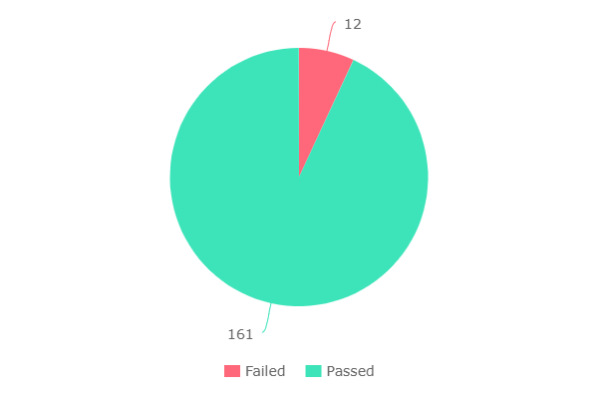

### No. of test cases planned vs executed & No. of test cases passed/failed (Group B)

|  |  |  |  |
| --- | --- | --- | --- |
| **Test cases planned** | **Test cases executed** | **TCs Pass** | **TCs Failed** |
| 150 | 150 | 131 | 19 |

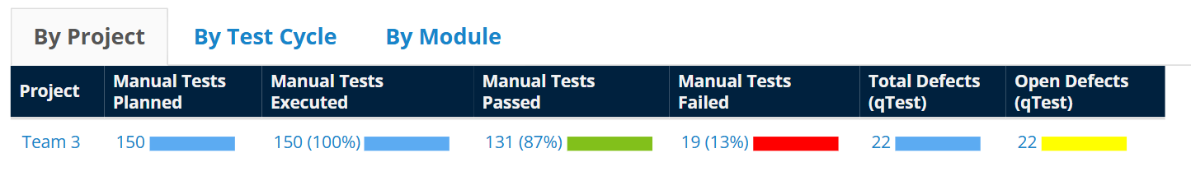

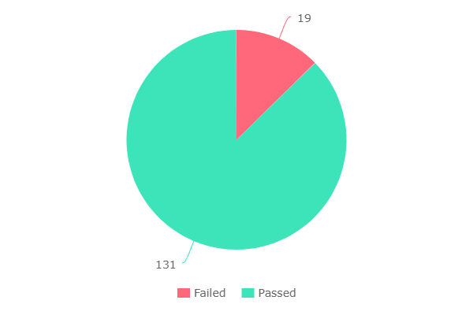

**No. of defects identified (Group A):**

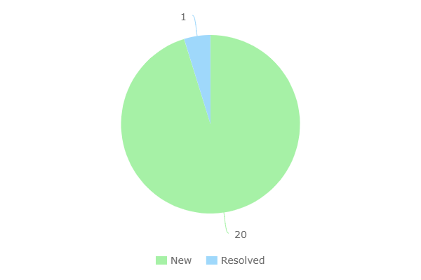

**No. of defects identified (Group B):**

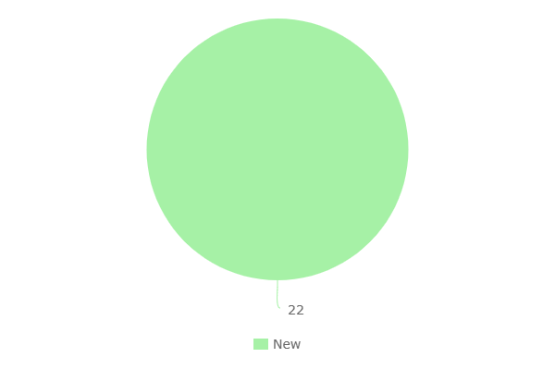

**Test Results by Day (Group A):**

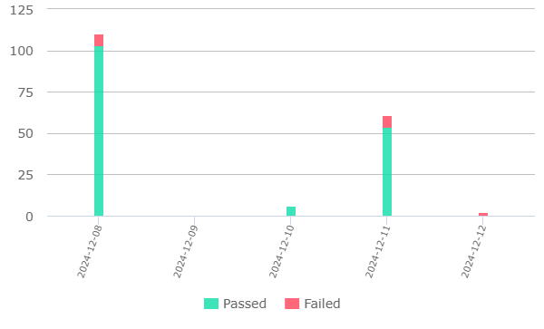

**Test Results by Day (Group B):**

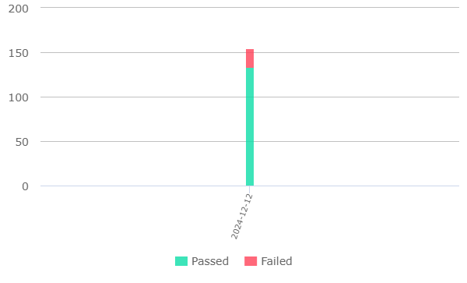

# Types of Testing Performed

#### ****System Testing:****

This involved end-to-end testing of the Xero system to verify that the modules met business and functional requirements. Specific scenarios, such as purchase order creation and expense claim approvals, were validated to ensure smooth operation.

#### ****Integration Testing:****

Testing focused on the interaction between modules, ensuring data integrity and accurate communication. For instance, integration between purchase orders and inventory management systems was tested to confirm proper data synchronization.

#### ****Functional Testing:****

All key functionalities were rigorously tested, including user workflows like submitting expense claims, approving purchase orders, and generating accounts payable reports. Detailed validation ensured compliance with predefined requirements.

#### ****Regression Testing:****

Post-fix testing was performed to confirm that bug resolutions or updates did not introduce new issues. Regression test cases were designed to assess previously tested functionalities.

# Test Environment & Tools

#### ****Environment Configuration:****

* **Operating System:** Linux CentOS 7.5
* **Database:** MySQL 8.0
* **Hardware:** Virtual Private Server (VPS) with 8 vCPUs, 16GB RAM, and 200GB SSD storage
* **Application URL:** <https://www.xero.com>
* **Devices Tested:** Desktop (Windows/macOS) and mobile (iOS/Android)
* **Browsers Tested:** Chrome, Firefox, Safari, and Edge (latest versions)

#### ****Testing Tools:****

* **Test Management:** JIRA for managing and tracking test cases.
* **Defect Logging:** JIRA for reporting and prioritizing defects.
* **Automation Support:** Selenium scripts for automated functional tests.

#### ****Security Measures:****

* Access was restricted to authorized personnel with credentials to ensure data privacy and test environment integrity.

# Lessons Learnt

1. **Communication Challenges:**

* **Issue:** Limited communication caused delays in resolving test case conflicts.
* **Solution:** Implemented a centralized platform (Slack) for regular team updates.

1. **Inconsistent Documentation:**

* **Issue:** Variations in test case format led to inconsistencies.
* **Solution:** Standardized documentation templates and conducted training sessions.

1. **Knowledge Sharing:**

* **Issue:** Gaps in module-specific expertise among team members.
* **Solution:** Organized cross-training workshops to build comprehensive understanding.

# Recommendations

1. **Enhance Communication:** Use collaborative tools and maintain clear channels for status updates.
2. **Improve Documentation Practices:** Adopt standardized templates for consistency.
3. **Facilitate Knowledge Sharing:** Schedule regular sessions for cross-functional knowledge transfer.

# Best Practices

1. **Define Test Cases:** Predefine detailed test cases with expected outcomes to ensure coverage.
2. **Leverage Automation:** Use tools like Selenium for repetitive tasks to increase efficiency.
3. **Maintain Logs:** Track test results and defects systematically for easy reference.

# Exit Criteria

* All planned test cases executed successfully.
* High and medium-severity defects resolved.
* Application stability demonstrated through multiple testing cycles.

# Conclusion/Sign Off

The Xero Cloud-Based Accounting System modules have undergone rigorous testing, meeting all defined exit criteria. The system is deemed stable and ready for deployment. As a next step, conducting User Acceptance Testing (UAT) is recommended to validate the application against user expectations.

# Definitions, Acronyms, and Abbreviations

· **UAT:** User Acceptance Testing

· **Defect:** A deviation from expected behavior in the application.

· **JIRA:** Project management and issue tracking software.

· **qTest:** Test management tool for organizing and tracking test cases.